**Game research --- 19 games**

***1. Super Mario & Kirby***The gameplay of the two games is similar, the player does not use weapons directly to destroy the enemy, but through other means such as Super Mario by jumping on the enemy to destroy the enemy, Star Kirby by swallowing the enemy to gain the ability of the enemy to destroy other enemies. (Kirby can only swallow one enemy at a time and must not be touched by the enemy when he has not swallowed the enemy or he will die).

**Advantage**

1.Classic, simple gameplay requires no teaching (Suitable for children)

2.There is no need to draw additional pictures of weapons

3.Developers don't need to worry about blood bars, enemies will die after receiving one hit

**Disadvantage**

1.The graphic designer doesn't need to draw weapons, but he does need to draw special abilities that the player gets from swallowing enemies or eating mushrooms (the player's new image). Like the player gets bigger/smaller, can breathe fire…

2.For developers, it may be necessary to design more moves, such as double jump, wall jump, roll, flight, etc

**Some thoughts:** The game style can be low pixel style, reducing the workload of the graphic designer, in addition to most of the free material on the Internet is low pixel.

**Super Mario video link: [Super Mario Bros. (1985) Full Walkthrough NES Gameplay [Nostalgia] (youtube.com)](https://www.youtube.com/watch?v=rLl9XBg7wSs)**

**Kirby video link: [Sell like magic with new AI tools (youtube.com)](https://www.youtube.com/watch?v=Db31Uo5bnys)**

***2. Dead Cells & Hollow Knight***Both games are more complex and play like Dark Souls, collecting different weapons to destroy enemies.

**Advantage**

1.In addition to the combat system, the game also adds the elements of collecting and solving puzzles and traps, and the gameplay is diversified.

2.Excellent background music, scenery

3.There's a backstory to the game

4.Set up a small map to facilitate the player to view the terrain

**Disadvantage**

1.Save points are small, requiring the player to have a high level of skill

2.More violent scenes (may not be suitable for children)

3.Graphic designers need to design images of different weapons

4.Game developers need to program more player actions

5.If the player gets a gun or a bow, the game developer may need to Disadvantageider the implementation of long-range weapon attacks

**Some thoughts:** Destroying enemies is not a necessary feature for this project, our users are children, and using weapons to attack enemies may bring some violent elements. If you want to add the ability to destroy enemies, Disadvantageider using Super Mario or Kirby. Or change the game type to a collectible puzzle game, which can block players through some squares, doors or traps to achieve the purpose of increasing the difficulty of the game.

**Link to the video of the dead cell： [Dead Cells - 2D Dark Souls! - Let's Play Dead Cells Gameplay (youtube.com)](https://www.youtube.com/watch?v=1mkX_uOydCk)**

**The Hollow Knight video link： [Hollow Knight: Silksong - Full Demo Gameplay (youtube.com)](https://www.youtube.com/watch?v=C5beQIv6K7g)**

***3. The Looter, The Red Selence & Altered Alma***  These games are not yet available, but some of the gameplay and design can be referenced. These games are set in the present or the future, and they are also designed to eliminate enemies to achieve the goal of clearing the level. But the weapons used were mostly firearms.

**Advantage**

1.The setting of the story is as planned (because of the need to collect code, the game cannot be set in a fantasy and magic world)

2. Compared to the previously mentioned games that have a new gameplay one of the games, players need to restore the scene power, in order to achieve the purpose of unlocking the map. (Until the power is restored, players can only see a small area of the surrounding scene, and players need to fight in the dark)

3.Some game scenarios may not require jumping, and the developer may not make the player jump feature

**Disadvantage**

1.Developers need to make gun-like weapons

2.There's a violent scene.

**Some thoughts:** Because the project's intended plan required players to collect code to finish the game, game graphic designers needed to Disadvantageider modern, cyberpunk style game-related graphics.

**The Looter video link: [The Looter - Official Trailer | Realms Deep 2023 (youtube.com)](https://www.youtube.com/watch?v=nSAknYWhUYs)**

**The Red Selence video link: [(50) The Red Selene - Official Trailer | Realms Deep 2023 - YouTube](https://www.youtube.com/watch?v=IT6zCINM-Vk)**

**Links to Altered Alma videos: [YouTube Audio](https://www.youtube.com/watch?v=nq0htYIByEk)**

***4. 7 Billion Humans & WHILE TRUE LEARN***Both games are games that the player needs to program, but the player does not need to write real code, but to combine or link the provided code modules to play, and these games can exercise people's programming logic ability.

**Advantage**

1. Unique gameplay (visual code blocks can be used to control the player)

2. No need to program complex actions

**Disadvantage**

1.Visualization of code modules can be a challenge for developers.

2. Developers need good coding logic

**Some thoughts:** These two games can provide inspiration for the anticipated planned collection code, unlocking the power supply part.

**7 Billion Humans video link：[Aurei Plays: 7 Billion Humans - 1 (youtube.com)](https://www.youtube.com/watch?v=Ch8FPWhZEDk&list=PLBYtGAFuKEUtoc_wRNNKLqdPxh3maLN4R)**

**WHILE TRUE LEARN video link：[(51) while True: learn() - Launch Trailer | PS4 - YouTube](https://www.youtube.com/watch?v=m3S14_RzoII)**

***5. Typoman & Sokobond***  Typoman is a collectible exploration game that influences the level of the environment by interacting with the letters that appear in the environment. Sokobond is a classic Sokobond game (combined with chemistry knowledge)

**Advantage**

1.No fighting required, a game to pass the time

2.Newbie friendly

3.Program development without complex actions

**Disadvantage**

1.There is no ready-made image material on the Internet, and it needs to be redesigned

**Typomanvideo link ：[Typoman Revised Walkthrough 100% (youtube.com)](https://www.youtube.com/watch?v=QwV9KTcw3ac)**

**Sokobond video link：[Sokobond - Part 1: Chemical Bonds (youtube.com)](https://www.youtube.com/watch?v=rcbLnG9Q5b4&list=PLgX5yD9FMWbdktAPKbV-BEnoQvScTut37)**

**6.*《Cave Story+》&《Shovel Knight》&《The Messenger》: Use weapons and equipment to defeat enemies***

**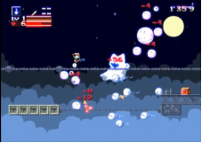  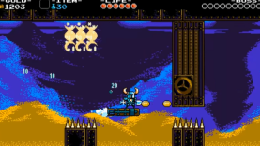  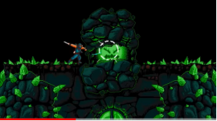**

**Advantage:**

1 Rich weapons and props as well as character selection

2 Carefully designed levels, players will Disadvantagetantly face new challenges and puzzles in the game

3 Introducing the time travel mechanism (the messenger), players can switch between past and future versions of levels

**Disadvantage:**

1 Game difficulty is high

2 The storyline is relatively simple

**Summary:**You can learn from the wonderful storylines and character designs in these games to design an engaging storyline to stimulate students' interest and curiosity, while at the same time delivering some beneficial values and educational content through the growth and development of the characters.

**Video link:<https://youtu.be/ZWkdtvyDj28?si=2IZO2PhWsNIFnjV0>**

**<https://youtu.be/bhG02JG7Sns?si=ZkYGAbit2sputV-3>**

**<https://youtu.be/qJf9edBS0TQ?si=VV11LUde5TCHgpfh>**

**7.*《Fez》: The [player-character](https://en.wikipedia.org/wiki/Player-character) Gomez receives a [fez](https://en.wikipedia.org/wiki/Fez_(hat)) that reveals his [two-dimensional](https://en.wikipedia.org/wiki/Two-dimensional) (2D) world to be one of four sides of a [three-dimensional](https://en.wikipedia.org/wiki/Three-dimensional) (3D) world. The player rotates between these four 2D views to realign platforms and solve puzzles. The objective is to collect cubes and cube fragments to restore order to the universe.***

**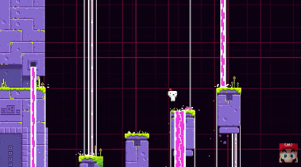    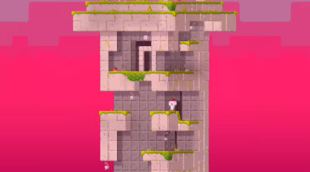**

**Advantage:**

1 Unique game mechanism: "Fez" is based on the conversion mechanism of 2D and 3D. Players can switch between plane and three-dimensional. This feature needs to be utilized during the puzzle solving process.

2 Beautiful pixel art style: The game has a beautiful pixel art style, and various scenes and characters are carefully and creatively designed.

3 Rich puzzle design: The puzzle designs in the game are very diverse, including environmental puzzles, symbol puzzles, music puzzles, etc.

4 Strong explorability: "Fez" has the explorability of an open world. Players can freely explore the game world and discover hidden areas and secrets.

5 A world full of mystery: The background of the game is mysterious and fantastic, and players can unlock the story clues behind the game through exploration.

**Disadvantage:**

1 The puzzle solving process may be too complex, may require players to spend a lot of time and energy to understand and solve.

2 The conversion mechanism is not intuitive enough, it may take some time to adapt.

3 Certain areas are difficult to explore: Some areas in the game may be designed to be hidden, and players may need to work hard to discover them.

**Summary:**

1 Simple and creative game mechanics

2 Rich puzzle design

3 Open world exploration and discovery

4 A balance of education and fun

5 Adaptable and personalised learning

**Video link:<https://youtu.be/lrEsNI0aCPk?si=BHWAMVmcFkQIrExa>**

**8.《*Teslagrad》: Use magnetism and other electromagnetic forces to pass levels***

**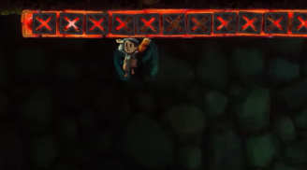    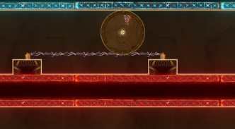**

**Advantage:**

1 Unique magnetic puzzle mechanism: Players can use magnetism to attract and repel objects and solve various interesting puzzles and challenges.

2 Exquisite art style: The background scenes and character designs of the game are exquisite and exquisite, and the visual effects are very good.

3 Rich and diverse puzzle design: The puzzle design in the game is very rich and diverse, involving various elements such as magnetism, electromagnetic force, mechanisms and obstacles.

4 Dialogue-free narrative method: The game adopts a dialogue-free narrative method, showing the story through the environment, scenes and character actions, allowing players to interpret and experience the story of the game world on their own.

5 Exploratory

**Disadvantage:**

1 Highly challenging: The puzzles and challenges in the game are relatively difficult and may have a certain learning curve for some players, requiring a certain amount of time and patience to solve.

2 Unclear story narrative: Since the game adopts a dialogue-free narrative method, some players may feel that the story narrative is not clear and clear enough to understand the background and storyline of the game world.

3 High repetitiveness: You may encounter some repetitions of puzzles and scenes in the game, causing players to feel a little monotonous and boring in some places.

**Summary:** We need to have our own innovation points

**Video link:<https://youtu.be/hRDkVcJr9UU?si=XZZLdIL_Qf5MQFn4>**

**9.*《Unravel》*: *The game centers on Yarny, a small anthropomorphic creature made of yarn, and players can navigate the environment, using the unraveling yarns that make up Yarny to solve puzzles, avoid dangerous creatures, and traverse obstacles.***

**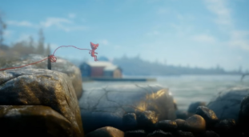    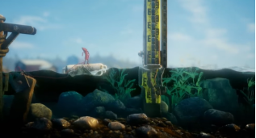**

**Advantage:**

1 Touching storyline: The game tells the story of a red thread (Yarny) searching for lost memories. The plot is warm, touching and thought-provoking.

2 Innovative game mechanism: Players manipulate a red line and use the extension and shortening of the line to solve various puzzles. This game mechanism is unique and creative, making the game full of challenge and fun.

3 Rich and diverse puzzle designs: The puzzle designs in the game are rich and diverse, including platform jumping, environmental interaction, physical mechanisms and other elements, allowing players to enjoy different types of puzzle challenges in the game.

4 Beautiful music soundtrack and exquisite artistic style

**Disadvantage:**

1 Unbalanced puzzle difficulty: Some puzzles are too easy and others are too difficult, which can lead to players feeling frustrated or bored at certain points.

2 Short game length: Players may feel that the game is not long enough to fully experience the depth and fun of the game.

3 Linear game progression: Players can only advance along a fixed route, lacking a certain degree of freedom and exploration.

**Summary:**

1 Game Mechanism: Design a similar unique game mechanism that allows students to control characters or objects through programming to solve puzzles and explore, thereby exercising their logical thinking and programming abilities.

2 Emotionally resonant storyline: Design a story that resonates emotionally with students, allowing them to experience themes such as growth, adventure, and friendship in the game, thereby stimulating learning interest and motivation.

**Video link:<https://youtu.be/t5Mpzi6-Zr0?si=U3MqRC7b5omNP7zQ>**

***10.《Braid》: Using abilities such as time manipulation, players complete the game by finding and assembling puzzle pieces.***

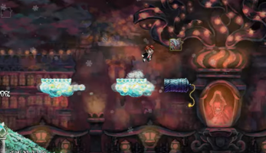

**Advantage:**

1 Innovative game mechanism: Players can go back in time at any time and try to solve puzzles and challenges again.

2 The game screen is rich in color and the scene details are exquisite.

3 Rich and diverse puzzle designs

4 Inspiring storyline

**Disadvantage:**

1 High difficulty: The puzzle design of the game is relatively complex and may require players to spend more time and energy to solve it.

2 The storyline is abstract and can be confusing at times.

**Summary:**Sufficient hints and guidance need to be provided in the game to avoid making players feel confused and helpless.

**Video link:<https://youtu.be/oNS7kBfG6Mk?si=KNMJ234IWgozJmGS>**

***11.《The Swapper》: Players control a female scavenger trapped in an abandoned research station and discovers a strange device (a handheld cloning tool) that allows her to create clones of herself and switch her Disadvantageciousness between them , use this ability to solve various puzzles and learn the fate of the space station's researchers.***

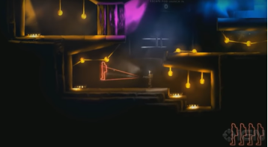

Advantage:

1 Unique game mechanism: Using a unique "copy and swap" mechanism, players can copy characters and swap positions with them to solve puzzles.

2 Deep philosophical thinking: Through exploration and puzzle solving in the game, players can think about profound issues such as self, identity and Disadvantageciousness.

Disadvantage: The puzzle design is relatively complex and the storyline is profound

Summary: Balance game difficulty

Video link:<https://youtu.be/Ls7e6OQRBZw?si=nduPWCshD67Vi4gk>